Greedy Algorithm
Sort: sort jobs in non-decreasing order, sort jobs by finish times so that $f_{1}≤f_{2}≤…≤f_{n}$
Initialize: define __ as__, create solution set $A←∅,$record the end time of the last selected task $last←0$
Iteratively select: Traversing the array/ sorted __, check if __ then __. Output: calculate__, return
We proof greedy algorithm is optimal by contradiction. $→$Greedy is optimal.
- Assume there exists an optimal solution (OPT) with a __ greater than the one found by greedy (GREEDY).
- Let $G_{1}({OPT}_{1})$, $G_{2}({OPT}_{2})…, G_{i}({OPT}_{i})$ denote the set of ___ selected by GREEDY(OPT).
- Let’s consider the first operation where OPT and GREEDY differ. Find i be the first value that
$G_{1}={OPT}_{1}$,…, $G_{i-1}={OPT}_{i-1}$, $G_{i}≠{OPT}_{i}$, [或者$G_{i}∈OPT\backslash GREEDY,G_{j}∈GREEDY\backslash OPT$]
- By definition of GREEDY,
- it has included all possible students that satisfy the inequality, which means ${OPT}_{max}≤ G_{max}$
- ”Exchange argument”: replacing x with y in $OPT$does not decrease(increase) total revenue. $∆_{1}-∆_{2}≥0$. Repeatedly exchanging such pairs transforms ${OPT}_{k}$ to $G_{k}$ without reducing(increasing) revenue and still feasible, which contradicts OPT > GREEDY.
- ”Cut lemma”: When e * was added by the algorithm, it connected two components C1 and C2, where C1, C2$⊂$ V. OPT must contain a path P connecting C1 and C2, which includes a road e crossing the cut (C1, C2). Since the algorithm chooses the smallest edge across this cut, d(e *) ≤ d(e), where d() is the distance of connections. Replace e with e * in OPT. The new set OPT ‘ =OPT \ {e} $∪$ {e ′} is still connecting all cities, and its total distance satisfies: d(OPT’) = d(OPT) − d(e) + d(e ′ ) ≤ d(OPT). [旅游城市最小生成树]
This contradicts the assumption that OPT is strictly better than GREEDY.
课程：Interval Scheduling($f_{i}$) / Scheduling to Minimize Lateness($d_{i}$)/ Minimum Spanning Tree($w(e)$)
Single-link k-clustering(删除最小生成树中k - 1条权最大的边)/ Optimal Caching(Farthest-In-Future, FF)
高买低卖：不连续高买低卖可以拆分成连续的高买低卖 优先队列 priority queue：每次从优先队列中移除两个最短的数组，合并为一个新数组，重新放入优先队列。将这两个数组的长度之和累加到总成本中。
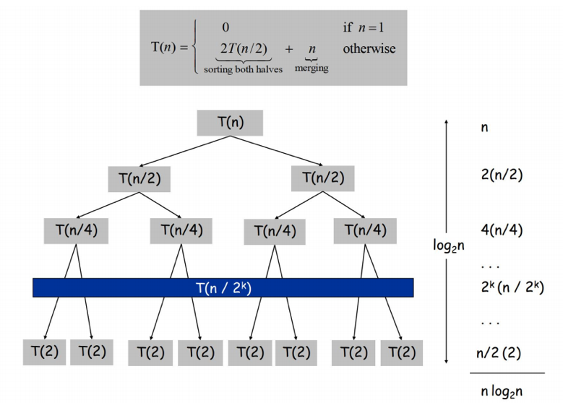
Divide and conquer proof by recursion tree
Divide step: We divide the set/array of __ into two roughly equal halves.
Recursively find ___ for both the left and right halves
until each subarray has a length of 1 or 0.
Combine step: For the left and right halves,
->find ___ span both halves. [Compare it with ____ the left
and right halves, and take the largest value as the
maximum value of the current interval. ]
->Recursively call merge sort to sort each of the two
subarrays, then merge the two sorted subarrays into a
single sorted array.[Merge sort]
Time complexity: The time complexity of combine step is O(n) for sequence length of n, and each subproblem of left and right halves requires T(n/2). The recurrence relation is: T(n) = 2T(n/2) +O(n).
Thus the overall time complexity is O(n log n).
binary search: We start by checking the middle element of the array. If A[ n/ 2 ] =_ , we have found the desired index. Otherwise, we can recursively search the left half if A[ n/ 2 ] > _or the right half if A[ n/ 2 ] <_ when the array is ascending, vice versa.
quickselect: Randomly choose a pivot element from ∆.Partition ∆ into three subarrays: elements smaller than the pivot, equal to the pivot, and larger than the pivot.Recurse only into the subarray that contains the m-th element. On average, QuickSelect runs in O(n) time, which is more efficient than full sorting O(n log n)
课程：Closest Pair of Points[$Θ\left(nlogn\right)或Θ\left(n\right)$]/ Integer Multiplication [$Θ\left(n^{2}\right)→Θ\left(n^{\log_{2}^{3}}\right)$]/
Matrix Multiplication [$Θ\left(n^{3}\right)→Θ\left(n^{\log_{2}^{7}}\right)$]/ Mergesort [$Θ(nlogn)$]/ FFT [$Θ(nlogn)$]
最大连续子和: 例子/ 逆序数：递归计算左、右子序列的逆序数；计算跨子序列的逆序对；合并累加逆序数
Dynamic Programming e(剩余图)=f($e^{R}$)+c(e)-f(e)
State Definition: Define __as__ State Transition: Boundary conditions; case1; case2; transition equation
Weighted Interval Scheduling: O(nlogn)
p(j) = largest index i < j such that job i is compatible with j, ${OPT\left(j\right)=max⁡\{v}_{j}+OPT\left(p\left(j\right)\right),OPT(j-1)$}
Knapsack Problem: $Θ(nW)$ Not polynomial in input size! “Pseudo-polynomial.” NP-complete
$$OPT\left(i,w\right)=w-w_{i}:max⁡\{opt\left(i-1,w\right),v_{i}+opt\left(i-1,w-w_{i}\right\};w_{i}>w:opt\left(i-1,w\right);i=0:0.$$
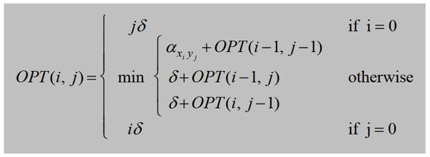
RNA Secondary Structure: $O(n^{3})$ 子串长度*子串起始位置*遍历t
${max⁡\{{}_{t∈T}^{max}{\{1+OPT\left(i,t-1\right)+OPT(t+1,j-1)}⁡}_{ }\},OPT\left(i,j-1\right)$} T:$i≤t<t-1$,$b_{t},b_{j}$ can be pairs
Sequence Alignment: $Θ\left(nm\right)$ O(m+n) 无法恢复具体比对结果
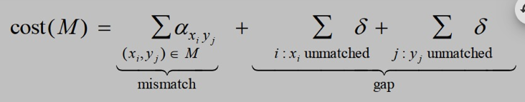

Shortest Paths：Dijkstra算法负权重$×$重加权法：长边短边$×$OPT(i, v)为从v到t、用不超i条边的最短路长。
$OPT\left(i,v\right):i=0,v≠t:∞; v=t:0; other:min⁡\{OPT\left(i-1,v\right),{}_{(v,w)∈E}^{\min{ }}{\{opt\left(i-1,w\right)+c_{vw}\}\}}$ ,无负成本环OPT(n-1)
零钱兑换：$OPT\left(i\right)=min⁡\{OPT\left(i\right),OPT\left(i-c\left[j\right]\right)+1\}$, initialize $OPT\left(0\right)=0,OPT\left(i\right)=inf,i-c\left[j\right]<0$
兑换方案：$OPT\left(i,j\right)$用前i种凑出j. $j-c\left(i\right)<0:OPT\left(i-1,j\right)$, $j-c\left(i\right)=0:OPT\left(i-1,j\right)+1$
$j-c\left(i\right)>0:OPT\left(i-1,j\right)+OPT(i,j-c\left(i\right))$
打家劫舍：k=1：$M_{1}$; k=2:$max⁡\{M_{1},M_{2}\}$; $k≥3:max⁡\{f\left(k-1\right),M_{k}+f(k-2)\}$
棋盘礼物最大价值： $i=j=1:M_{11};$ $i=1,j>1:M_{1j}+f(1,j-1)$ ; $j=1,i>1:M_{i1}+f(i-1,1)$;
$i>1,j>1:max⁡\{f\left(i-1,j\right)+M_{i,j},f\left(i,j-1\right)+M_{i,j}\}$
混插字母：M[i, j] = T if and only if (M[i − 1, j] = T and A[i] = C[i + j]) or (M[i, j − 1] = T and B[j] = C[i + j]).
双色打印：$s\left[i\right]≠s\left[j\right]:opt\left(i,j\right)= \min_{k=i}^{j-1}\{opt(i,k)+opt(k+1,j\}$; $s\left[i\right]=s\left[j\right]:opt(i,j-1)$
卖石头：$opt\left(i,j\right)= max⁡\{P_{i,j},\max_{1≤k<i}\{opt\left(k,j\right)+opt\left(i-k,j\right)-j\}+\max_{l}\{opt\left(i,l\right)+opt\left(i,j-l\right)-i\}\}$
切割布料：$opt\left(j\right)= \max_{1≤i<j}\{opt\left(j-i\right)+price[i]\}$
交易股票 j天不超过i次：$opt\left(i,j\right)= max⁡\{opt(i,j-1),\max_{1≤m<j}\{opt\left(i-1,m\right)+pric\left[j\right]-pric[m]\}$;$\max_{i}$
插删替单词匹配：$si=sj: \max\left\{opt\left(i,j-1\right),opt\left(i-1,j\right),opt\left(i-1,j-1\right)+1\right\};si≠sj:opt\left(i-1,j-1\right)$
Network Flow adjacent 相邻的 vertex 顶点 Residual Graph 剩余图 integrality theorem 整数流定理
The augmenting path is ___. The capacity of this path is min( , , )= Ford-Fulkerson: O(mnC) 指数级
改进：外层循环O(log C)次，每次内层循环O(m)次增广，每次增广需O(m)时间，总时间复杂度为$O(m^{2}\log{C)}$。
Network construction: Node setEdge and capacity set: a source s and a sink t;
Create a directed edge from s to __, with the capacity of the edge set to __
Bipartite Matching(人挑狗，一人一只) 增加s,t, (s,L)1 (L,R)$∞$ (R,t)1
Edge Disjoint Paths 每条边的容量设为1，assign unit capacity to every edge，转化为最大流问题
Circulation Problems 增加 s,t, 对于v(d(v)<0): (s,v)-d(v); v(d(v)>0): (s,v)d(v)
问卷调查： (s-客户i)[$c_{i}$-$c_{i}'$], (客户i-产品j)[0,1], (产品i-t) [$p_{i}$-$p_{i}'$]，(s,t) [0,$∞]$ 是否存在整数环流
图像分割：对每个像素i，(s, i) $a_{i}$；(i, t)$b_{i}$；(j, i)$p_{ij}$ 最小割容量$\sum_{B}{a_{i}}+\sum_{A}{b_{i}}+\sum_{ }{p_{i}}$为原最大化的补
棒球比赛：($s,x-y$) $g_{xy}剩余比赛$ ($x-y,x/y$)$g_{xy}$; ($x,t$)$w_{3}+r_{3}-w_{x}所有边容量饱和 则未淘汰$
项目选择：if (v,w)∈E: (w,v) $∞$ If pᵥ>0: (s,v) pᵥ; If pᵥ<0: (v,t) -pᵥ; pₛ=pₜ=0; 最优项目子集为A-{s}
网格最大礼物：checkerboard mincut(最小舍弃): ($s,黑$)p ($白,t$)p ($黑,白$)$∞$ maxgift = 总价值-f(最大流/)
象棋最大骑士：总-最多有多少对互相攻击的骑士mincut: (s,白)1; (黑,t)1 (白,黑)if 攻击 $∞$else无边
工厂运货村庄：($s,f_{i}$) $p_{i}$ ($f_{i},v_{j}$) $c_{i}$ ($v_{j},t$) $d_{j}$ check if maximum flow value f = $\sum{d_{i}}$
Asymptotic Notation A dominate B add/minus/multiple/divided by lower-order terms omitted
For res1, the outer/middle/inner loop is executed n times, which is $O( ).$ The overall complex is __
The nested loops over indices i and j. / A __ step on an array of length n./ with a binary search inside.

